1. TCP Server

// A Java program for a Server
import java.net.*;
import java.io.*;

public class TCP_Server
{
//initialize socket and input stream
private static Socket socket = null;
private static ServerSocket server = null;
private static DataInputStream in = null;

// constructor with port
public static void main(String args[])
{
// starts server and waits for a connection
try
{
server = new ServerSocket(5000);
System.out.println("Server started");

System.out.println("Waiting for a client ...");

socket = server.accept();
System.out.println("Client accepted");

// takes input from the client socket
in = new DataInputStream(
new BufferedInputStream(socket.getInputStream()));

String line = "";

// reads message from client until "Over" is sent
while (!line.equals("Over"))
{
try
{
line = in.readUTF();
System.out.println(line);

}
catch(IOException i)
{
System.out.println(i);
}
}
System.out.println("Closing connection");

// close connection
socket.close();
in.close();
}
catch(IOException i)
{
System.out.println(i);
}
}

}

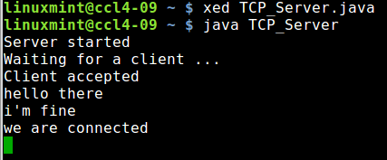

2. TCP Client

// A Java program for a Client
import java.net.*;
import java.io.*;

public class TCP_Client
{
// initialize socket and input output streams
private static Socket socket = null;
private static DataInputStream input = null;
private static DataOutputStream out = null;

// constructor to put ip address and port
public static void main(String args[])
{
// establish a connection
try
{
socket = new Socket("127.0.0.1", 5000);
System.out.println("Connected");

// takes input from terminal
input = new DataInputStream(System.in);

// sends output to the socket
out = new DataOutputStream(socket.getOutputStream());
}
catch(UnknownHostException u)
{
System.out.println(u);
}
catch(IOException i)
{
System.out.println(i);
}

// string to read message from input
String line = "";

// keep reading until "Over" is input
while (!line.equals("Over"))
{
try
{
line = input.readLine();
out.writeUTF(line);
}
catch(IOException i)
{
System.out.println(i);
}
}

// close the connection
try
{
input.close();
out.close();
socket.close();
}
catch(IOException i)
{
System.out.println(i);
}
}

}

